***Creating, Opening, and Removing Files through the Command Line***

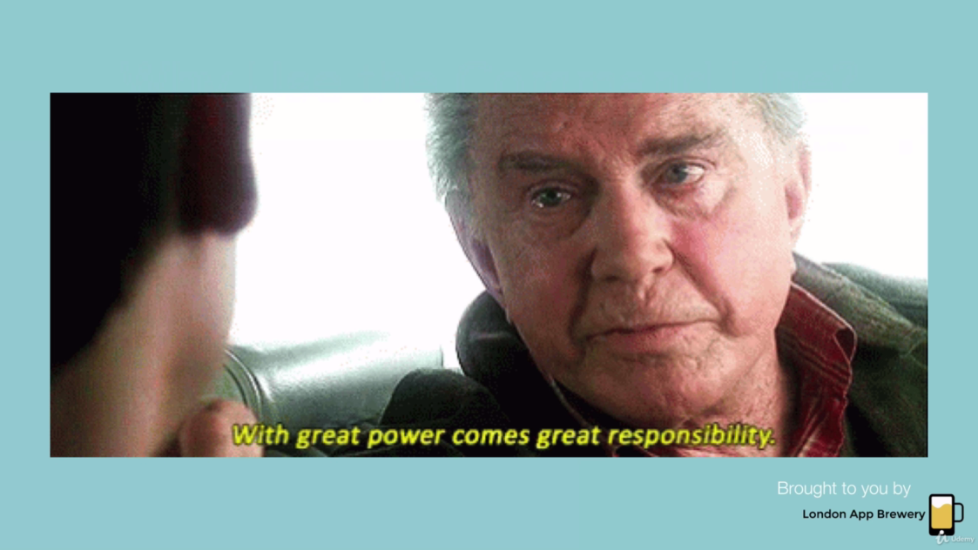

Let’s create folder using cmd inside **15. The Unix Command Line**

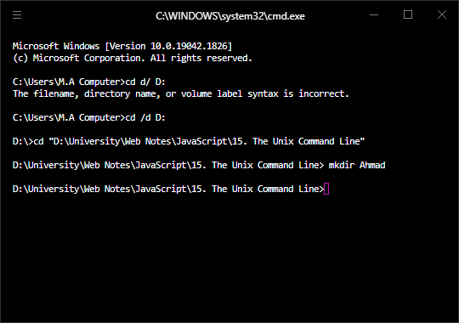

Ahmad folder is created .

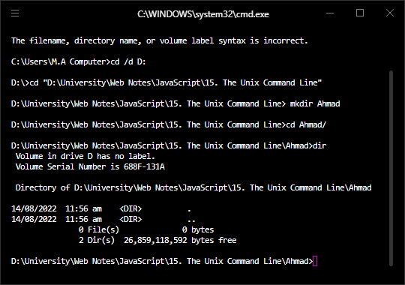

At this time nothing in directory.

Now add notepad file in Ahmad and check **dir**

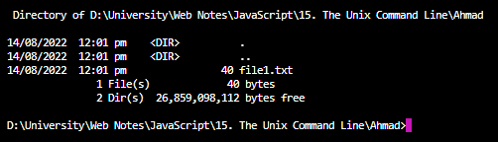

Now there’s one file.

Now let’s **create file using command line**

In linux **touch filename.txt** like touch file2.txt

In windows **nul> filename.txt**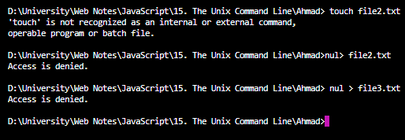

File 2 and 3 are created.

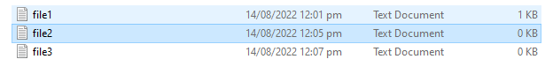



**Open text file using command:**

Simply write file-name.txt



This will open the file

**Open file in other editors using command line:**

Editor-name filename.txt

Like open file in atom

**Atom file1.txt**



**Open complete folder in atom:**

Command: Atom . (Atom space dot)



**Delete files using command line:**

dir to check directory.

**del "<filename>"**

Change file name/ rename file

ren oldname newname

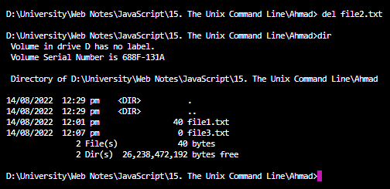

Now there are two files instead of 3.



**Delete all the files using cmd:**

**del  *.** **txt**

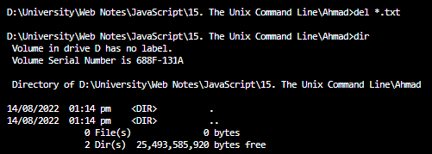

del *.png for pics

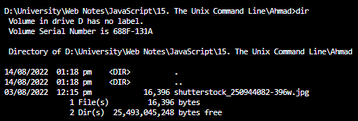

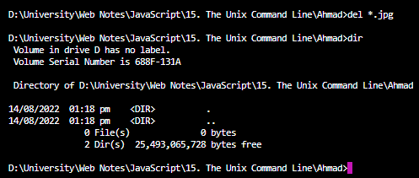

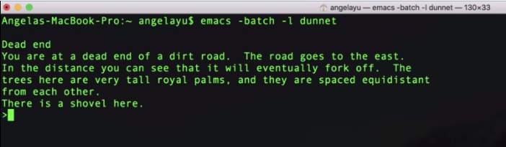

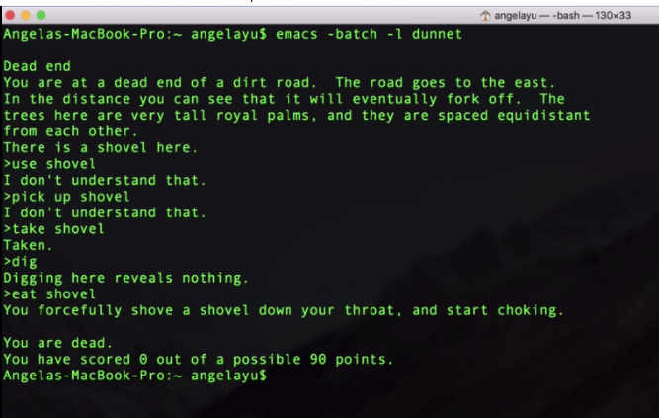

<https://gist.github.com/kiedtl/06f728a414a7804826c378b214bf7726>